Assignment 6

1)

2) 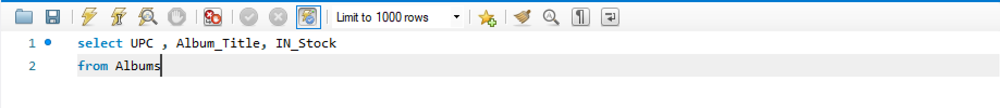

3) 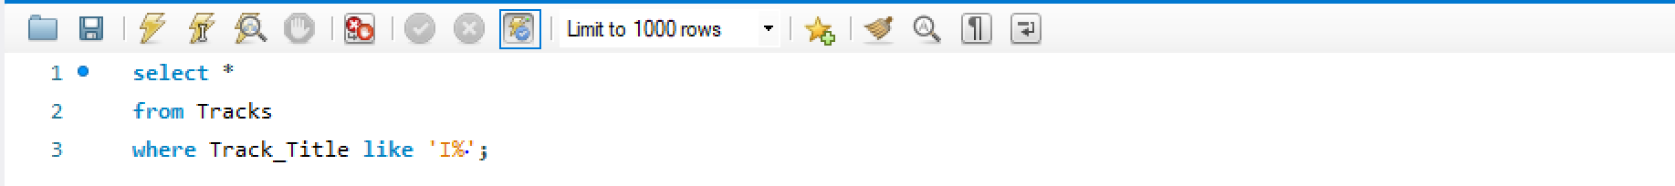

4)

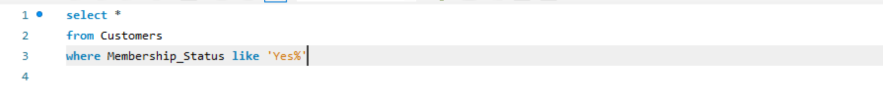

5)

6)

7)

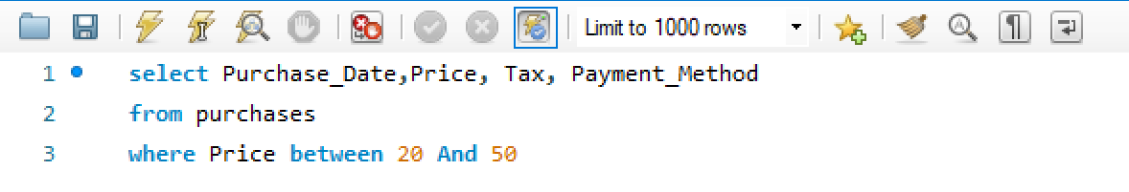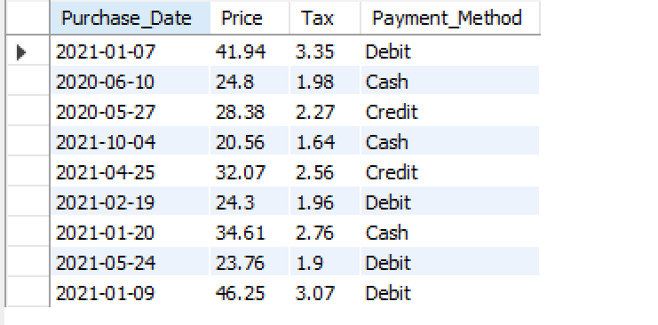

8)

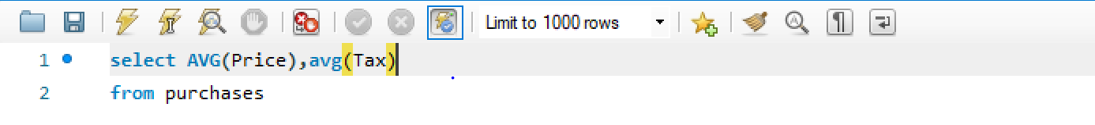

9)

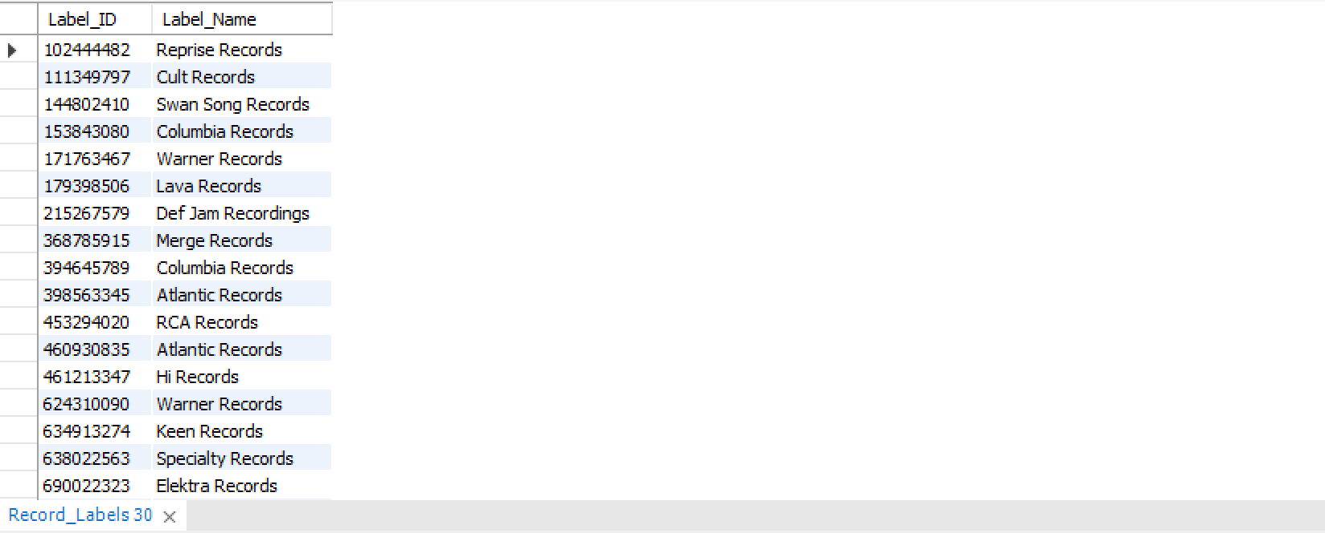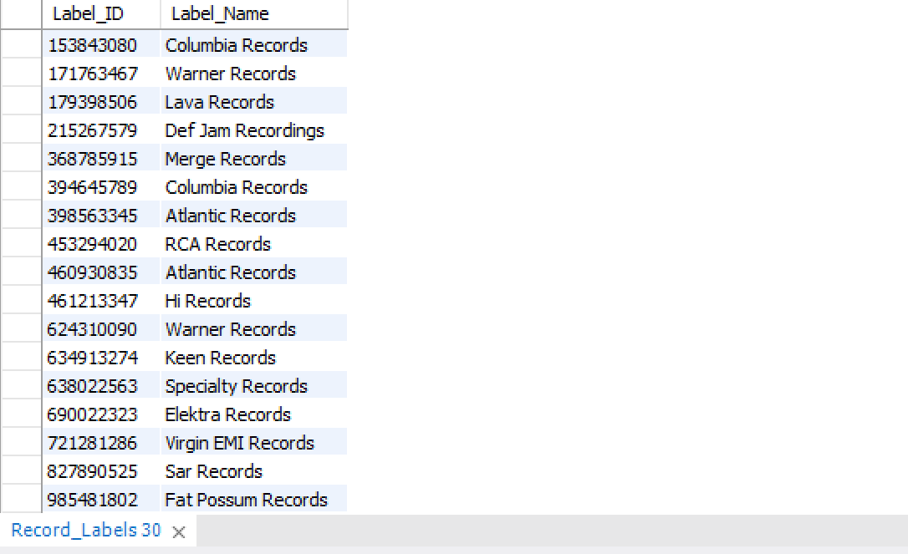

10)

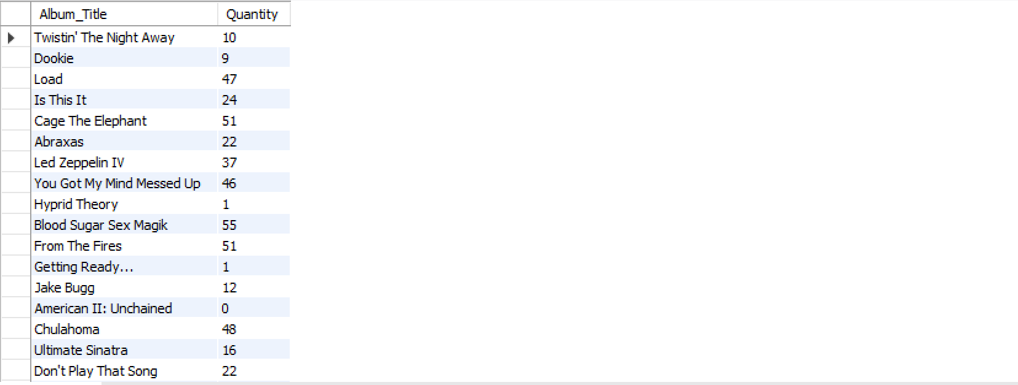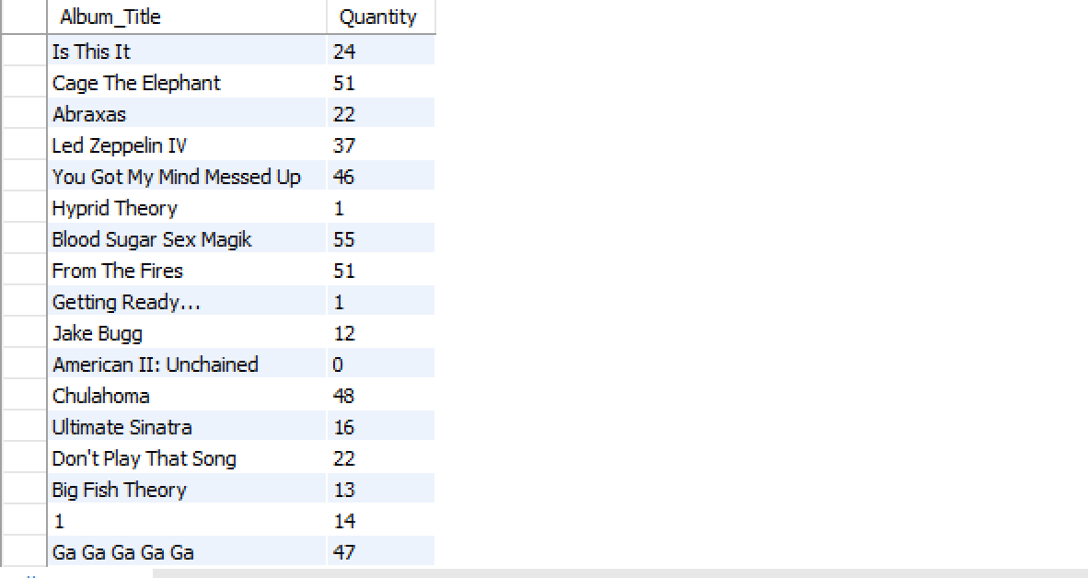

11)

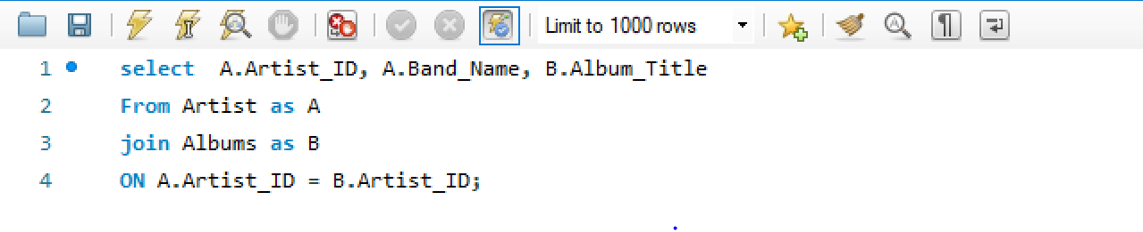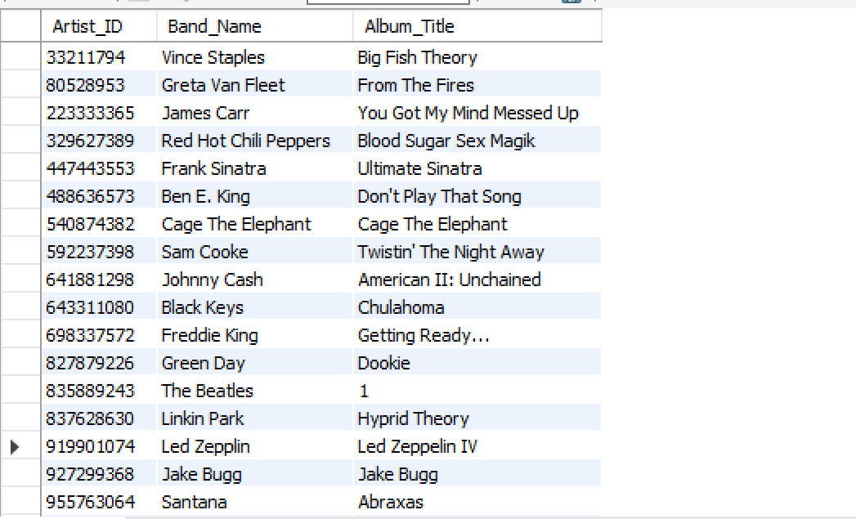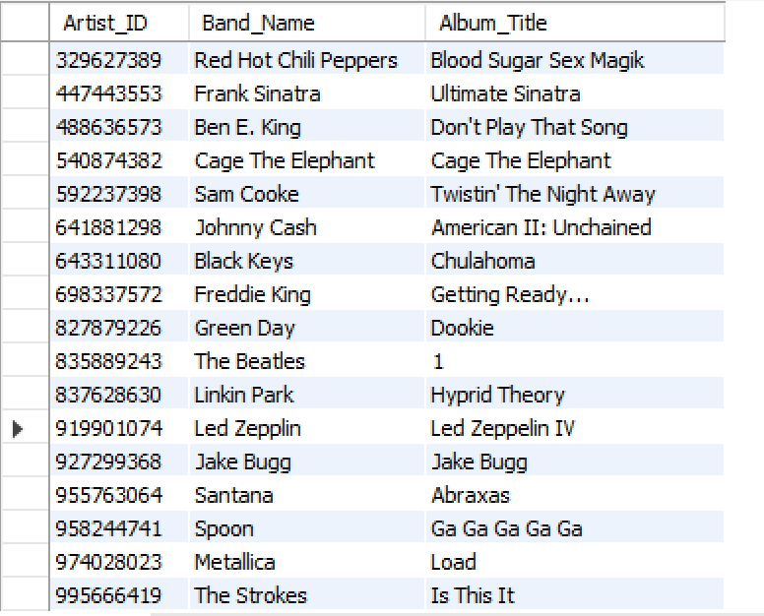

12)

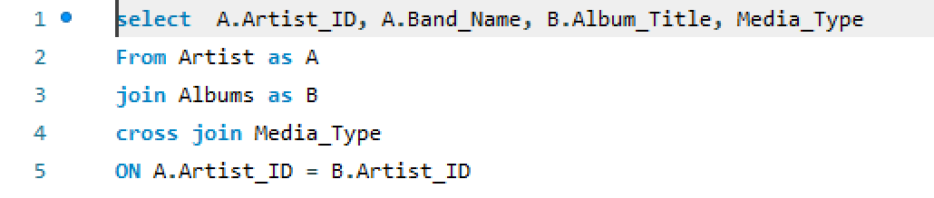

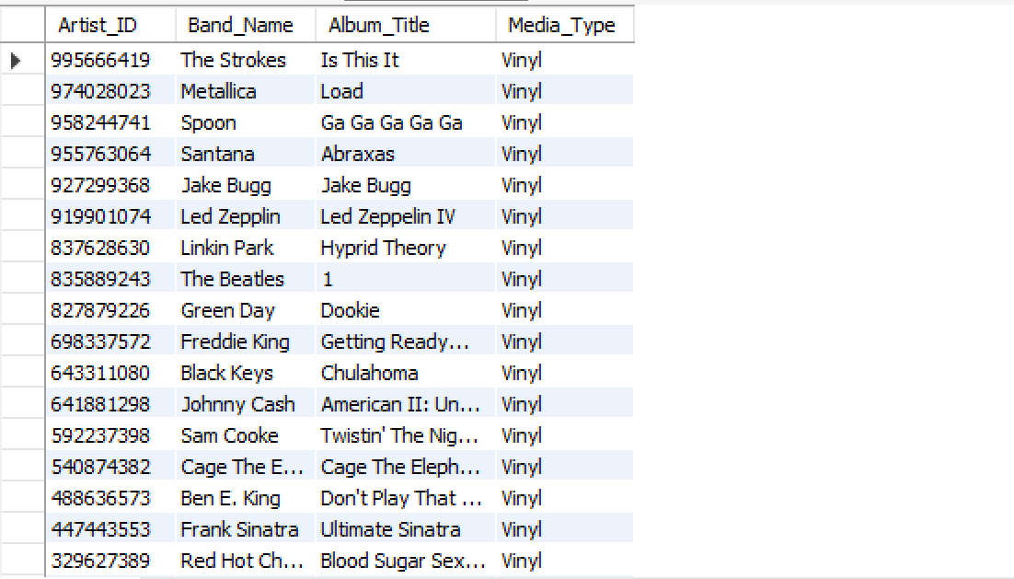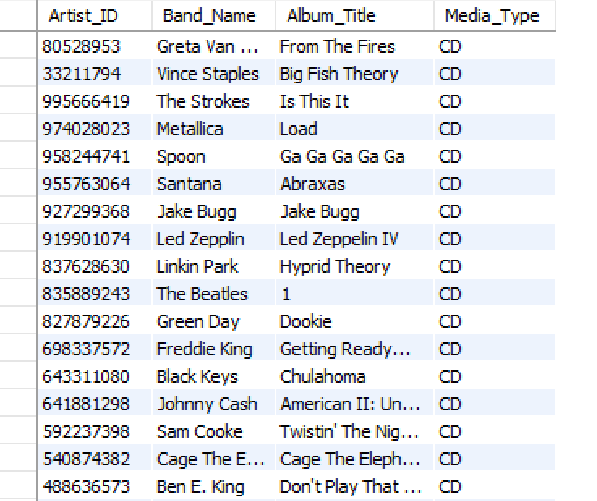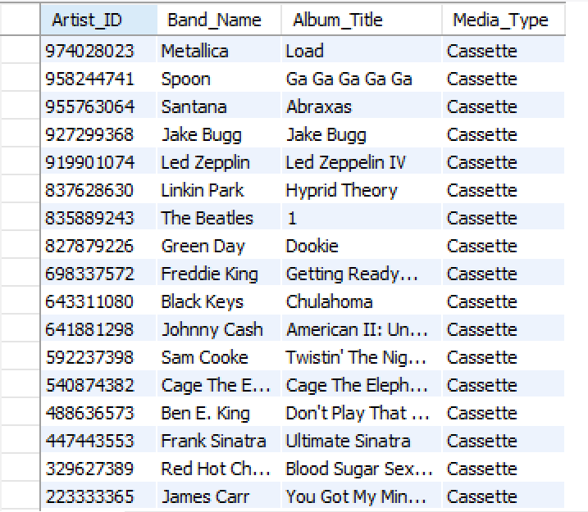

13)

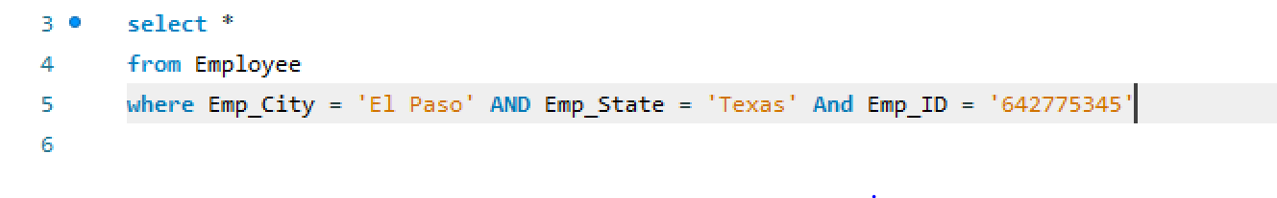

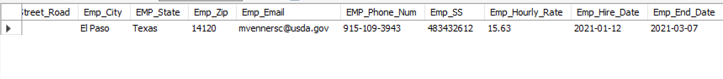

14)

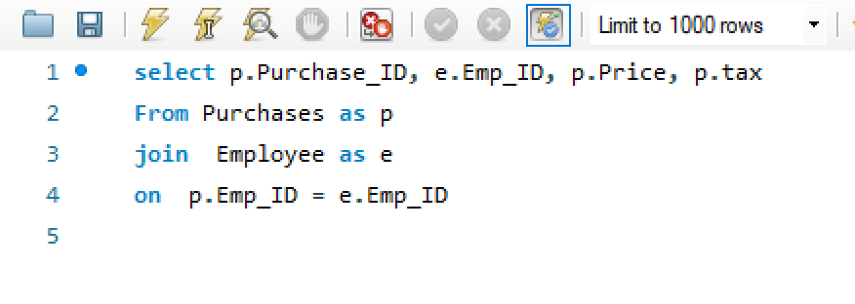

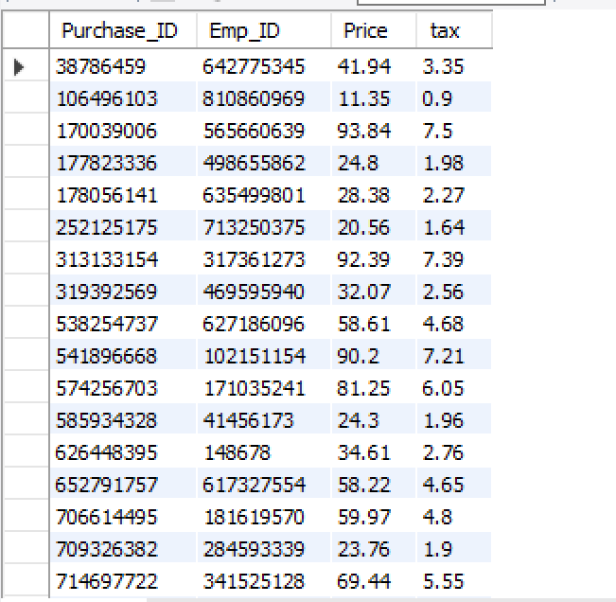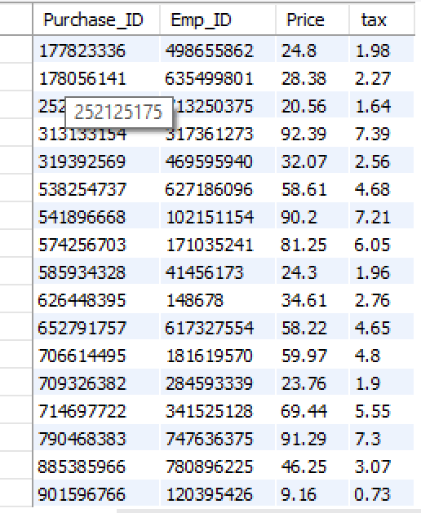

15)

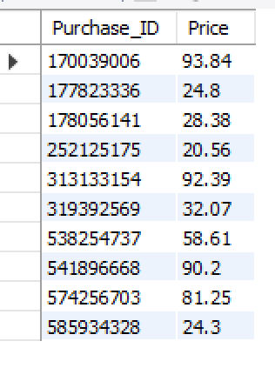

16)

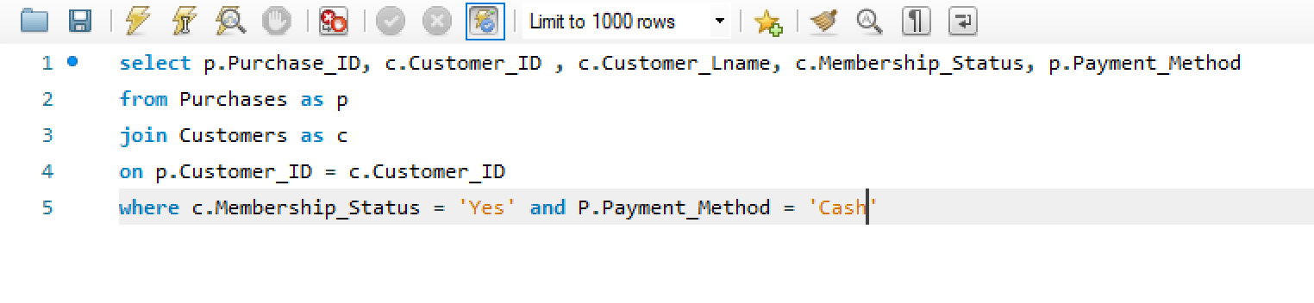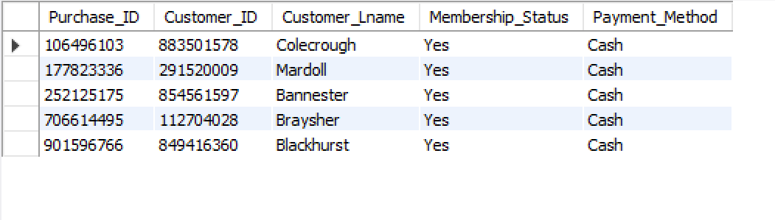

17)

18)

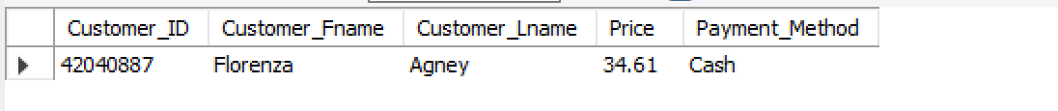

19)



20)

